BRACT’s
Vishwakarma Institute of Technology, Pune
Practical Implementation Sheet
Department: CSE-AI Semester: 5 Academic Year: 2026-27
Division: E Batch:3 Practical No: 5
Roll no: 58 PRN No: 12412806 Name of Student: Shadab Hussain
Subject Name : Deep Learning

1. Introduction
This report presents a comparative study of three recurrent neural network architectures — Simple RNN, LSTM, and GRU — applied to binary sentiment classification on the IMDB movie reviews dataset. The dataset contains 50,000 labelled reviews, evenly split between positive and negative sentiment. Each model was trained under identical preprocessing and hyperparameter conditions so that differences in performance can be attributed to the architecture itself.

2. Dataset Overview
The IMDB dataset was loaded and inspected before preprocessing. It contains 50,000 rows across two columns: the review text and its sentiment label, with no missing values and a perfectly balanced class distribution (25,000 positive, 25,000 negative).
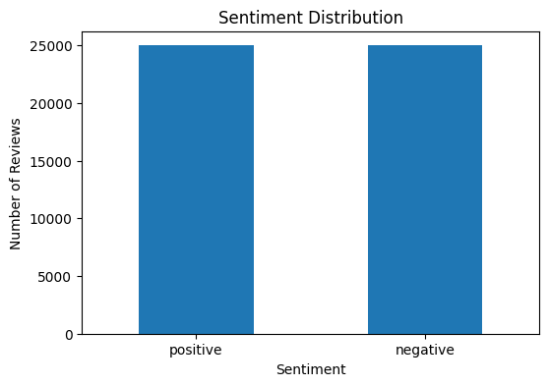
Figure 1: Sentiment class distribution across the dataset.

3. Data Preprocessing
- Sentiment labels were mapped to numerical values (positive = 1, negative = 0).
- Reviews and labels were separated into feature (X) and target (y) arrays.
- An 80/20 train-test split produced 40,000 training and 10,000 testing samples.
- A Keras Tokenizer restricted vocabulary to the 10,000 most frequent words (out of 111,959 unique words found).
- Text sequences were tokenized to integers and padded/truncated to a fixed length of 200 tokens.

4. Model Architectures
Three sequential models were built, each starting with an Embedding layer followed by a single recurrent layer (SimpleRNN, LSTM, or GRU respectively), a Dropout layer for regularization, and a final Dense output layer with sigmoid activation for binary classification.

4.1 Simple RNN
model = Sequential([
Embedding(max_words, embedding_dim, input_length=max_length),
SimpleRNN(units, dropout=0.2, recurrent_dropout=0.2),
Dropout(0.5),
Dense(1, activation='sigmoid')
])

4.2 LSTM
model = Sequential([
Embedding(max_words, embedding_dim, input_length=max_length),
LSTM(units, dropout=0.2, recurrent_dropout=0.2),
Dropout(0.5),
Dense(1, activation='sigmoid')
])

4.3 GRU
model = Sequential([
Embedding(max_words, embedding_dim, input_length=max_length),
GRU(units, dropout=0.2, recurrent_dropout=0.2),
Dropout(0.5),
Dense(1, activation='sigmoid')
])

5. Training
Each model was trained for 5 epochs on the padded training sequences, with a held-out validation split monitored after every epoch. Training time was recorded for each architecture.

5.1 Training Summary
- Simple RNN: final training accuracy 59.5%, validation accuracy 51.7% — training time 105.00 s.
- LSTM: final training accuracy 87.2%, validation accuracy 84.6% — training time 213.68 s.
- GRU: final training accuracy 95.9%, validation accuracy 87.6% — training time 170.48 s.
The Simple RNN struggled to learn meaningful patterns across the 200-token sequences, a well-known limitation caused by vanishing gradients over long sequences. Both gated architectures (LSTM and GRU) converged to substantially higher accuracy, with GRU training faster than LSTM while reaching comparable — and ultimately slightly higher — validation accuracy. Epoch-by-epoch validation curves for all three models are shown in Section 6.4.

6. Evaluation on Test Set
All three models were evaluated on the same held-out test set of 10,000 reviews. The table below summarizes accuracy, precision, recall, F1-score, test loss, and training time.
Model | Accuracy | Precision | Recall | F1 Score | Test Loss | Train Time (s)
RNN | 0.5076 | 0.5143 | 0.2736 | 0.3572 | 0.7234 | 105.00
LSTM | 0.8467 | 0.8503 | 0.8416 | 0.8459 | 0.3582 | 213.68
GRU | 0.8667 | 0.8798 | 0.8494 | 0.8644 | 0.3764 | 170.48

6.1 Accuracy Comparison
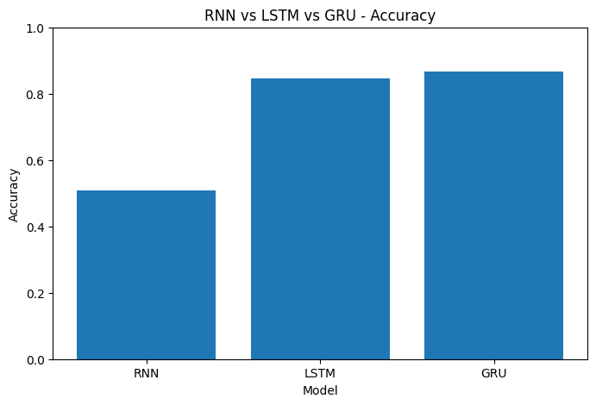
Figure 2: Test accuracy comparison across RNN, LSTM, and GRU.

6.2 All Metrics Comparison
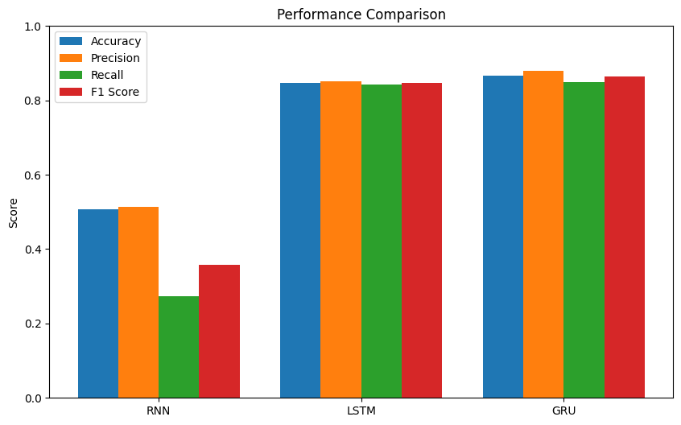
Figure 3: Accuracy, precision, recall, and F1-score compared across models.

6.3 Training Time Comparison
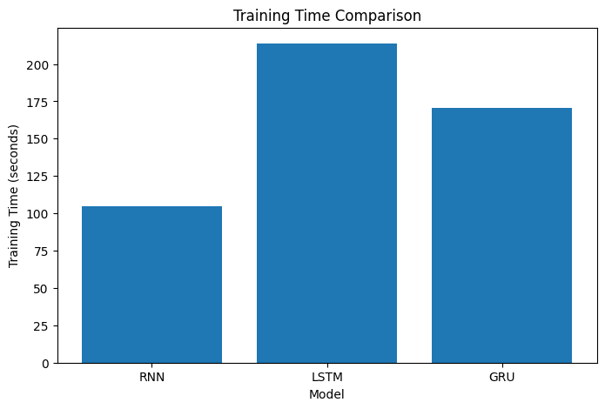
Figure 4: Training time (seconds) for each architecture.

6.4 Validation Accuracy Curves
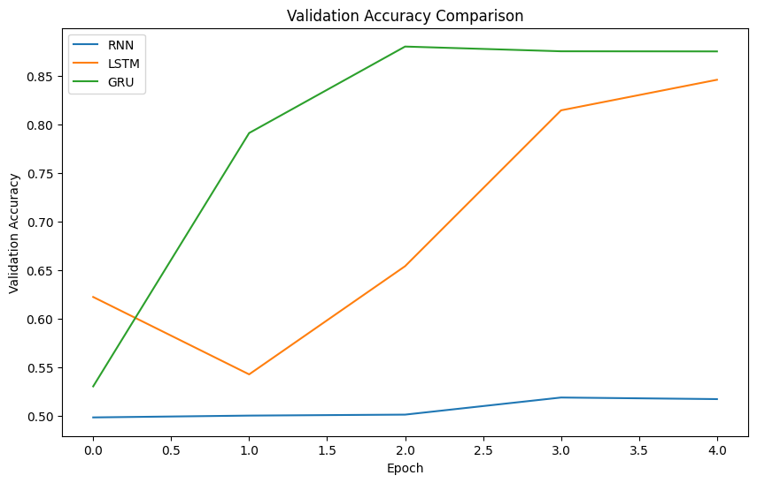
Figure 5: Validation accuracy across epochs for all three models.

6.5 Validation Loss Curves
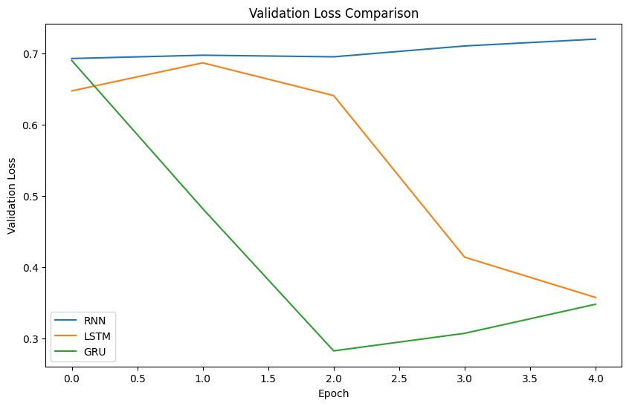
Figure 6: Validation loss across epochs for all three models.

7. Confusion Matrices
Confusion matrices illustrate each model's classification behaviour on the 10,000-sample test set, split evenly between negative and positive reviews.
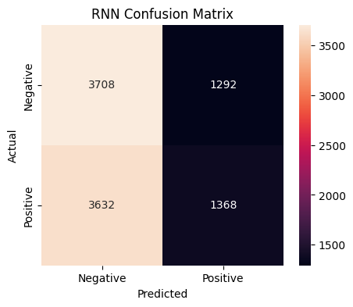
Figure 7: RNN confusion matrix — heavily biased toward predicting the negative class.
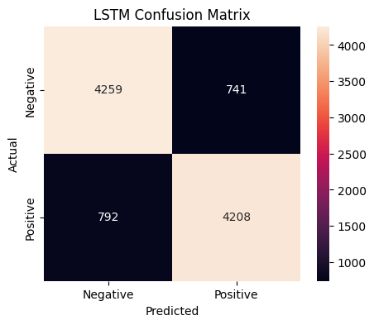
Figure 8: LSTM confusion matrix — balanced classification with high accuracy.
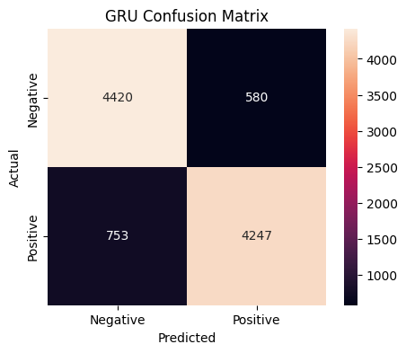
Figure 9: GRU confusion matrix — the strongest overall separation between classes.

8. Classification Reports

8.1 RNN
Class | Precision | Recall | F1-Score | Support
Negative | 0.51 | 0.74 | 0.60 | 5000
Positive | 0.51 | 0.27 | 0.36 | 5000
Accuracy |  |  | 0.51 | 10000
Macro avg | 0.51 | 0.51 | 0.48 | 10000
Weighted avg | 0.51 | 0.51 | 0.48 | 10000

8.2 LSTM
Class | Precision | Recall | F1-Score | Support
Negative | 0.84 | 0.85 | 0.85 | 5000
Positive | 0.85 | 0.84 | 0.85 | 5000
Accuracy |  |  | 0.85 | 10000
Macro avg | 0.85 | 0.85 | 0.85 | 10000
Weighted avg | 0.85 | 0.85 | 0.85 | 10000

8.3 GRU
Class | Precision | Recall | F1-Score | Support
Negative | 0.85 | 0.88 | 0.87 | 5000
Positive | 0.88 | 0.85 | 0.86 | 5000
Accuracy |  |  | 0.87 | 10000
Macro avg | 0.87 | 0.87 | 0.87 | 10000
Weighted avg | 0.87 | 0.87 | 0.87 | 10000

9. Conclusion
Across every evaluation metric, GRU achieved the best overall performance (86.67% test accuracy, 0.8644 F1-score) while training faster than LSTM. LSTM followed closely behind (84.67% accuracy, 0.8459 F1-score). The Simple RNN performed only marginally better than random guessing (50.76% accuracy), confirming its known difficulty in capturing long-range dependencies in text due to vanishing gradients. For this sentiment classification task, gated recurrent architectures — particularly GRU — offer the best trade-off between accuracy and training efficiency.

